Design and apply context-aware access controls based on user identity, device posture, location, and application risk.

Design and apply context-aware access controls based on user identity, device posture, location, and application risk.

List of Team Members:

S.No | Name | College | Contact
1. | Vidarshana.M | Sri Ramakrishna College of Arts & Science for Women | srcw2322k158@srcw.ac.in
2. | Sowmiya.M | Sri Ramakrishna College of Arts & Science for Women | srcw2322k152@srcw.ac.in
3. | Sowmiya.S | Sri Ramakrishna College of Arts & Science for Women | srcw2322k153@srcw.ac.in
4. | Swetha.S | Sri Ramakrishna College of Arts & Science for Women | srcw2322k155@srcw.ac.in

INTRODUCTION:
In today’s highly connected digital environment, organizations must ensure that access to their systems and data is granted only to the right users under the right conditions. With the rapid adoption of cloud computing, remote work, and mobile technologies, traditional security models that rely solely on passwords or network location are no longer sufficient. Cyber attackers increasingly exploit weak authentication mechanisms, compromised devices, and unauthorized access points to infiltrate organizational networks. As a result, modern security strategies must adopt more intelligent and adaptive approaches that evaluate multiple factors before granting access to sensitive resources.
Context-aware access control has emerged as a powerful solution to address these challenges. Unlike traditional access control methods that rely only on static credentials, context-aware systems evaluate a combination of dynamic factors before allowing a user to access an application or system. These factors include the identity of the user, the security posture of the device being used, the geographic location of the access request, and the risk level associated with the application being accessed. By analyzing these contextual signals in real time, organizations can make more informed and secure access decisions, ensuring that only legitimate users with secure devices and trusted conditions are allowed to proceed.
This project focuses on designing and applying context-aware access controls that enhance organizational security while maintaining user convenience. The system will verify user identity to ensure that the individual requesting access is authenticated and authorized. It will also assess the device posture by checking whether the device meets security requirements such as updated software, antivirus protection, and proper configuration. In addition, the system will evaluate the location of the user to detect unusual or suspicious access attempts, such as login requests from unfamiliar regions. Furthermore, the application risk level will be considered, ensuring that highly sensitive applications receive stricter security enforcement compared to lower-risk systems.
By combining these contextual elements, the proposed system can dynamically adjust security measures based on the level of risk involved. For example, a verified employee accessing a routine internal application from a trusted company laptop within the office network may be granted seamless access. However, if the same user attempts to access a critical application from an unknown device or unusual location, the system may require additional verification steps such as multi-factor authentication or may even block the request entirely. This adaptive approach not only strengthens security but also provides a balanced user experience by applying stricter controls only when necessary.
Ultimately, the implementation of context-aware access control will help organizations reduce security risks, prevent unauthorized access, and protect sensitive data from potential threats. By integrating user identity, device posture, location awareness, and application risk evaluation, this system represents a modern and proactive approach to cybersecurity. It enables organizations to move beyond traditional security models and build a flexible, intelligent access control framework that supports both strong protection and efficient operations in today’s dynamic digital landscape.

ABSTRACT:
The rapid growth of cloud computing, mobile devices, and remote work environments has significantly transformed the way organizations access and manage digital resources. Traditional access control mechanisms that rely only on usernames, passwords, or fixed network boundaries are no longer capable of addressing modern cybersecurity challenges. As employees access organizational systems from different devices, networks, and geographic locations, the risk of unauthorized access, data breaches, and credential misuse has increased substantially. Consequently, organizations require a more intelligent and adaptive security framework that can evaluate multiple contextual factors before granting access to sensitive systems and applications.
This project focuses on the design and implementation of a context-aware access control system that enhances security by analyzing various contextual elements associated with each access request. The system evaluates critical factors such as user identity, device posture, location, and application risk level to determine whether access should be granted or restricted. By considering these contextual attributes together, the system can make more accurate and secure access decisions compared to traditional static authentication methods. For example, the system verifies whether the user is authorized, checks if the device being used meets the required security standards, identifies the geographic location of the request, and determines the sensitivity level of the application being accessed.
The methodology of this project involves creating a policy-based framework that processes contextual signals and evaluates them against predefined security policies. These policies define different access conditions and corresponding responses, such as granting full access, requiring additional authentication steps like multi-factor authentication, limiting user privileges, or blocking the request entirely. Through this dynamic evaluation process, the system can respond appropriately to both low-risk and high-risk scenarios, ensuring that security measures are applied according to the level of threat involved.
The expected outcome of this project is the development of an adaptive and intelligent access control model that strengthens organizational security while maintaining a smooth user experience. By dynamically analyzing contextual information for every access attempt, the system reduces the likelihood of unauthorized access and protects critical resources from potential threats. At the same time, trusted users operating in secure environments can access applications with minimal disruption. Overall, this approach provides a modern and effective solution for managing secure access in today’s increasingly complex and distributed digital ecosystem.

USE CASE SCENARIOS:
Scenario 1: Human Resources Manager Access to Employee Records System
An HR manager needs to access the internal Human Resources Management System (HRMS) to update employee performance records and salary details. The manager connects from home using a company-managed laptop and launches the ZPA Client Connector. After authenticating through Azure Active Directory with multi-factor authentication (MFA), ZPA evaluates the user’s identity, role membership (HR Managers group), device posture (latest security patches installed, disk encryption enabled, and antivirus running), and connection context. Since all conditions meet the predefined security policies, the policy engine grants access through a secure micro-tunnel directly to the HRMS application. The manager can update employee records but cannot access other internal applications such as finance servers or development systems.
Output:
• User authenticated and verified as part of the HR Managers group
• Secure micro-tunnel established exclusively to the HRMS application
• Other internal systems remain hidden and inaccessible

Scenario 2: Research Team Access to Internal Data Analytics Platform
A member of the research and development team needs to access an internal data analytics platform to analyze product performance metrics. The employee connects from the corporate office using a company-managed workstation and logs in through the ZPA Client Connector. Authentication is performed via Azure Active Directory with MFA. ZPA evaluates the user’s identity, group membership (R&D Data Users), device compliance (updated OS, endpoint protection enabled), and network location (corporate office network). Based on the low-risk context and correct authorization, the system establishes a secure connection only to the analytics platform. The user can perform data queries and analysis but cannot access unrelated systems such as the payroll database or internal communication servers.
Output:
• User identity verified and authorized for the analytics platform
• Secure application-specific connection established
• Access limited only to the authorized data analytics platform

Scenario 3: Temporary Intern Access to Learning Management System
A summer intern in the training department needs access to the company’s Learning Management System (LMS) to complete onboarding courses and training materials. The intern logs in using a personal laptop through the ZPA Client Connector and authenticates with Azure Active Directory using MFA. ZPA evaluates the user’s identity and confirms their membership in the Intern_Training group. However, the device posture check indicates that the device is unmanaged. Based on policy rules, the system allows access only to the LMS web interface through a restricted session while blocking access to all other corporate applications.
Output:
• User authenticated as an intern with limited privileges
• Access restricted only to the Learning Management System
• All other internal resources blocked due to unmanaged device

Scenario 4: Security Analyst Monitoring Threat Intelligence Platform
A cybersecurity analyst needs to access the internal threat intelligence platform to monitor potential security threats and review system alerts. The analyst connects using a secure company workstation from the security operations center and launches the ZPA Client Connector. After authenticating through Azure Active Directory with MFA, ZPA evaluates the user’s identity, group membership (Security_Analysts), device posture (fully compliant security configuration), and location (trusted corporate network). Based on the trusted context, the system establishes a direct micro-tunnel connection to the threat intelligence platform while preventing access to unrelated internal systems such as HR records or financial applications.
Output:
• User authenticated and verified as a member of the Security_Analysts group
• Direct micro-tunnel established to the threat intelligence platform
• Access restricted strictly to security monitoring tools

Scenario 5: Sales Representative Accessing CRM System During Travel
A sales representative traveling for a client meeting needs to update customer information in the company’s CRM system. The representative connects using a company-managed tablet from a hotel Wi-Fi network and launches the ZPA Client Connector. After authenticating with Azure Active Directory and MFA, ZPA evaluates the user’s identity, role membership (Sales CRM Users), device posture (compliant with security standards), and network context (public network detected). Due to the higher risk associated with the public network, the policy engine allows access but enforces additional controls such as session monitoring and restricted file downloads. The user can update customer records but cannot export sensitive data from the CRM.
Output:
• User authenticated and device verified as compliant
• Access granted to CRM with additional security controls
• File export and sensitive data downloads restricted due to public network access

Stage – 1

Title:
Design and apply context-aware access controls based on user identity, device posture, location, and application risk.
Overview:
In the modern digital environment, organizations are increasingly relying on cloud applications, mobile devices, and remote work models to support their operations. While these advancements provide flexibility and productivity, they also introduce significant security challenges. Traditional access control mechanisms that rely on static credentials or network-based trust are no longer sufficient to protect sensitive systems and data. Attackers often exploit weak authentication, compromised devices, and unsecured networks to gain unauthorized access. As a result, organizations must adopt more intelligent and adaptive security strategies that evaluate multiple contextual factors before granting access to resources.
This project focuses on the design and implementation of a context-aware access control system that determines access privileges based on dynamic contextual information rather than simple login credentials. The system evaluates several critical factors including user identity, device posture, geographic location, and application risk level before allowing access to corporate resources. By analyzing these contextual signals together, the system can determine whether the access request is legitimate and whether additional security measures such as multi-factor authentication (MFA), session restrictions, or access denial should be applied. This approach ensures that access decisions are made in real time and are aligned with the security posture of the organization.
Despite advancements in authentication technologies, many organizations still face vulnerabilities due to traditional access control models. One major vulnerability is credential theft, where attackers gain access to legitimate usernames and passwords through phishing or malware. If access control relies only on credentials, attackers can easily impersonate legitimate users. Another vulnerability is the use of unmanaged or insecure devices, which may lack proper security updates, antivirus protection, or encryption. Such devices can serve as entry points for malware and unauthorized access. Additionally, access from untrusted or unusual locations can indicate potential account compromise, especially when login attempts originate from unfamiliar geographic regions or public networks.
Another significant risk involves high-risk applications containing sensitive organizational data, such as financial systems, customer databases, or internal administrative tools. Without proper access control policies, users may unintentionally gain broader access than required, violating the principle of least privilege. Furthermore, traditional network-based security often allows lateral movement, where attackers who gain initial access to one system can move across the network to compromise additional systems. These vulnerabilities highlight the need for a security model that continuously evaluates contextual information and enforces granular access policies.
To address these challenges, the proposed system integrates context-aware policy enforcement that dynamically adapts access decisions based on the risk level of each request. For example, a trusted employee accessing a low-risk application from a compliant corporate device within a trusted location may be granted seamless access. However, if the same user attempts to access a highly sensitive system from an unknown device or high-risk location, the system may require additional verification steps or restrict the session entirely. By continuously analyzing contextual factors, the system reduces the likelihood of unauthorized access while maintaining a smooth user experience for legitimate users.
Ultimately, this project aims to strengthen organizational cybersecurity by implementing a modern access control framework that combines identity verification, device security assessment, location awareness, and application risk evaluation. By addressing the vulnerabilities associated with traditional access control methods, the system helps protect sensitive resources, minimize the attack surface, and ensure that users only access the information necessary for their roles. This context-aware approach represents a proactive and effective strategy for securing digital environments in today’s increasingly distributed and threat-prone technological landscape.

List of Teammates:
S.No | Name | College | Contact
1. | Vidarshana.M | Sri Ramakrishna College of Arts & Science for Women | srcw2322k158@srcw.ac.in
2. | Sowmiya.M | Sri Ramakrishna College of Arts & Science for Women | srcw2322k152@srcw.ac.in
3. | Sowmiya.S | Sri Ramakrishna College of Arts & Science for Women | srcw2322k153@srcw.ac.in
4. | Swetha.S | Sri Ramakrishna College of Arts & Science for Women | srcw2322k155@srcw.ac.in

List of Vulnerability table:

S.No | Category Name | Vulnerability Name | CWE - No
1. | Broken Access Control | Unverified Ownership | 283
2. | Security Misconfiguration | Sensitive Cookie in HTTPS Session Without 'Secure' Attribute | 614
3. | Software Supply Chain Failures | Use of Obsolete Function | 447
4. | Cryptographic Failures | Not Using a Random IV with CBC Mode | 329
5. | Injection | XML Injection (aka Blind XPath Injection) | 91
6. | Insecure Design | Unprotected Primary Channel | 419
7. | Authentication Failures | Improper Validation of Certificate with Host Mismatch | 299
8. | Software or Data Integrity Failures | Improperly Controlled Modification of Dynamically-Determined Object Attributes | 915
9. | Security Logging & Alerting Failures | Omission of Security-relevant Information | 223
10. | Mishandling of Exceptional Conditions | Declaration of Throws for Generic Exception | 397

REPORT

1.Vulnerability Name: Unverified ownership
CWE: CWE-283
OWASP Category: A01:2025 Broken Access Control
Description:
Unverified Ownership occurs when a web application fails to properly verify whether the authenticated user actually owns or has permission to access a specific resource before allowing operations such as viewing, editing, or deleting it. This vulnerability typically appears when applications rely on user-supplied identifiers such as user IDs, account numbers, or object IDs without validating ownership on the server side.
In such cases, an attacker can manipulate request parameters (for example, changing an ID in a URL or API request) to access resources belonging to other users. Because the application does not check whether the resource belongs to the requesting user, unauthorized access becomes possible.
Business Impact:
If this vulnerability is exploited, attackers may gain unauthorized access to sensitive data or perform actions on resources belonging to other users. This can lead to data leakage, modification, or deletion of information that should be protected.
From an attacker’s perspective, the most valuable targets are resources owned by privileged users or administrators, as these accounts often have access to sensitive information or critical application functions. If an attacker successfully accesses or manipulates such resources, they may be able to view confidential data, modify records, perform actions on behalf of other users, or escalate their privileges within the application.
Such incidents can result in privacy violations, loss of customer trust, operational disruption, and potential financial or legal consequences for the organization.

Vulnerability path: http://testfire.net/

Steps to Reproduce:
- Access the URL

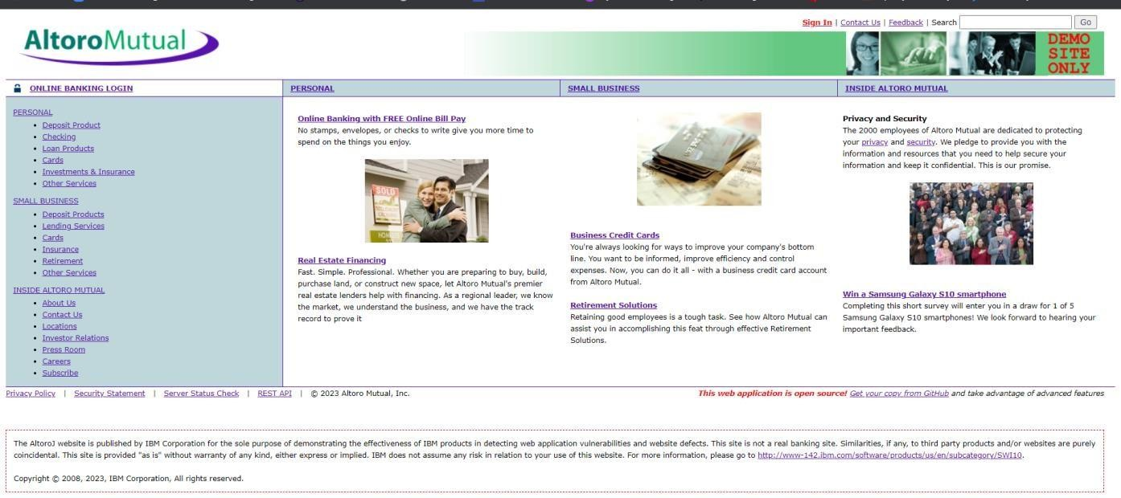

- In the search box we will input some code to perform the vulnerability.

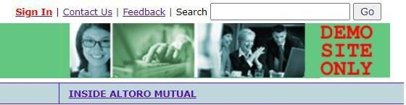

- The Script we will be inputting is '><script>alert('hacked')</script>
- This displays a harmless pop up alert box with the text saying ‘hacked’

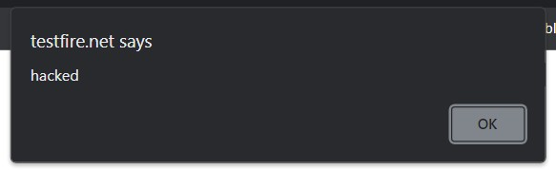

Recommendation:
- When interacting with databases, use parameterized statements or prepared statements to a

- void SQL injection, which can be a vector for XSS.
- Sanitize and validate all user inputs and ensure that any data displayed on the web page is properly encoded. Use output encoding libraries or functions to prevent script injection.

2.Vulnerability name: Sensitive Cookie in HTTPS Session Without 'Secure' Attribute
CWE:614
OWASP Category: A02:2025 Security Misconfiguration

Description:
This vulnerability occurs when a web application transmits sensitive cookies, such as session identifiers or authentication tokens, without enabling the Secure attribute. The Secure attribute ensures that cookies are only sent over encrypted HTTPS connections and are not transmitted through unencrypted HTTP requests.
When the Secure flag is not set, browsers may send these cookies over insecure HTTP connections, even if the application normally uses HTTPS. This exposes sensitive session information to potential interception by attackers who may be monitoring the network traffic.
As a result, attackers can capture these cookies using techniques such as network sniffing or man-in-the-middle attacks. Once the session cookie is obtained, the attacker may be able to impersonate the legitimate user and gain unauthorized access to the application.

Business Impact:
If exploited, this vulnerability can lead to session hijacking, where attackers take control of a valid user session without needing login credentials. By stealing the session cookie, the attacker can perform actions within the application as if they were the authenticated user.
From an attacker’s perspective, the most valuable targets are sessions belonging to users with elevated privileges, such as administrators or users who have access to sensitive business data. If such a session is compromised, attackers may gain access to confidential information, perform unauthorized transactions, or manipulate application data.
This can lead to data breaches, compromise of user accounts, reputational damage, and potential financial and legal consequences for the organization. Implementing the Secure attribute on cookies and enforcing HTTPS for all communications helps mitigate this risk.

Step 1: Website loaded in the burp server

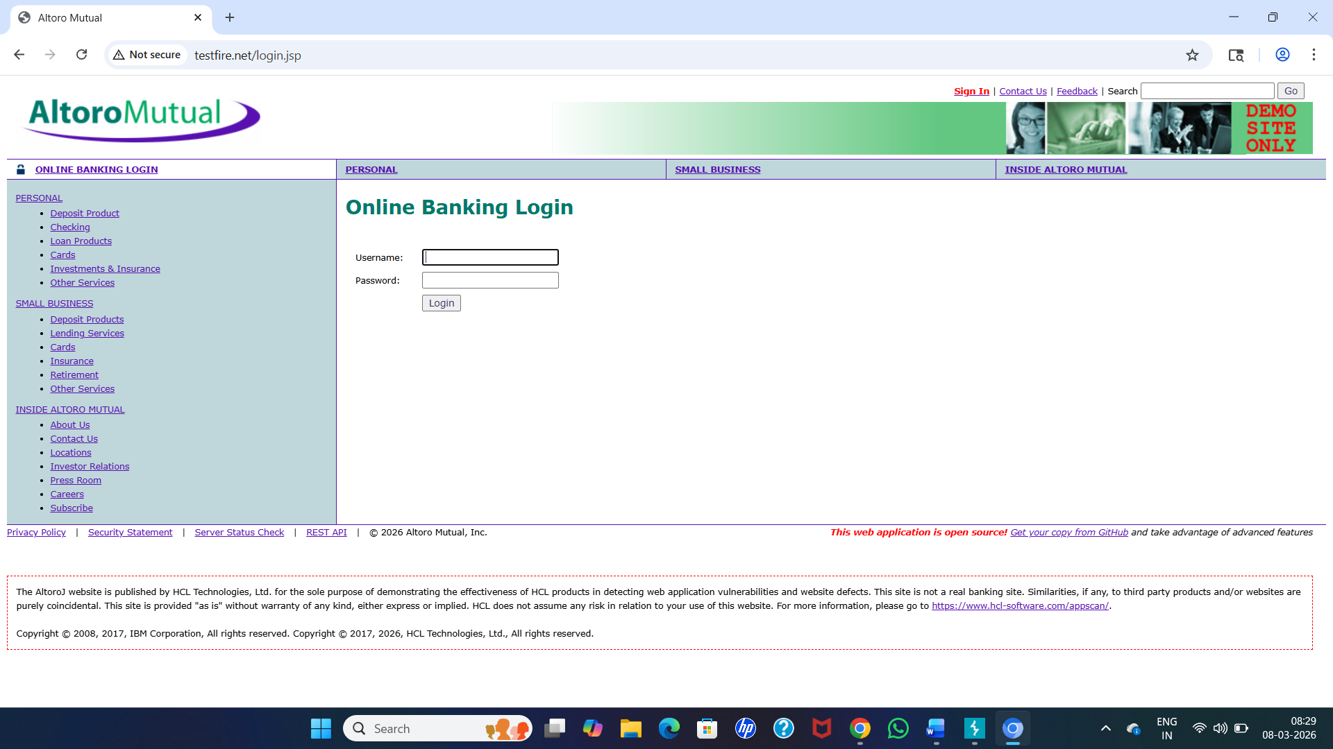

Step 2: Enter Login Credentials

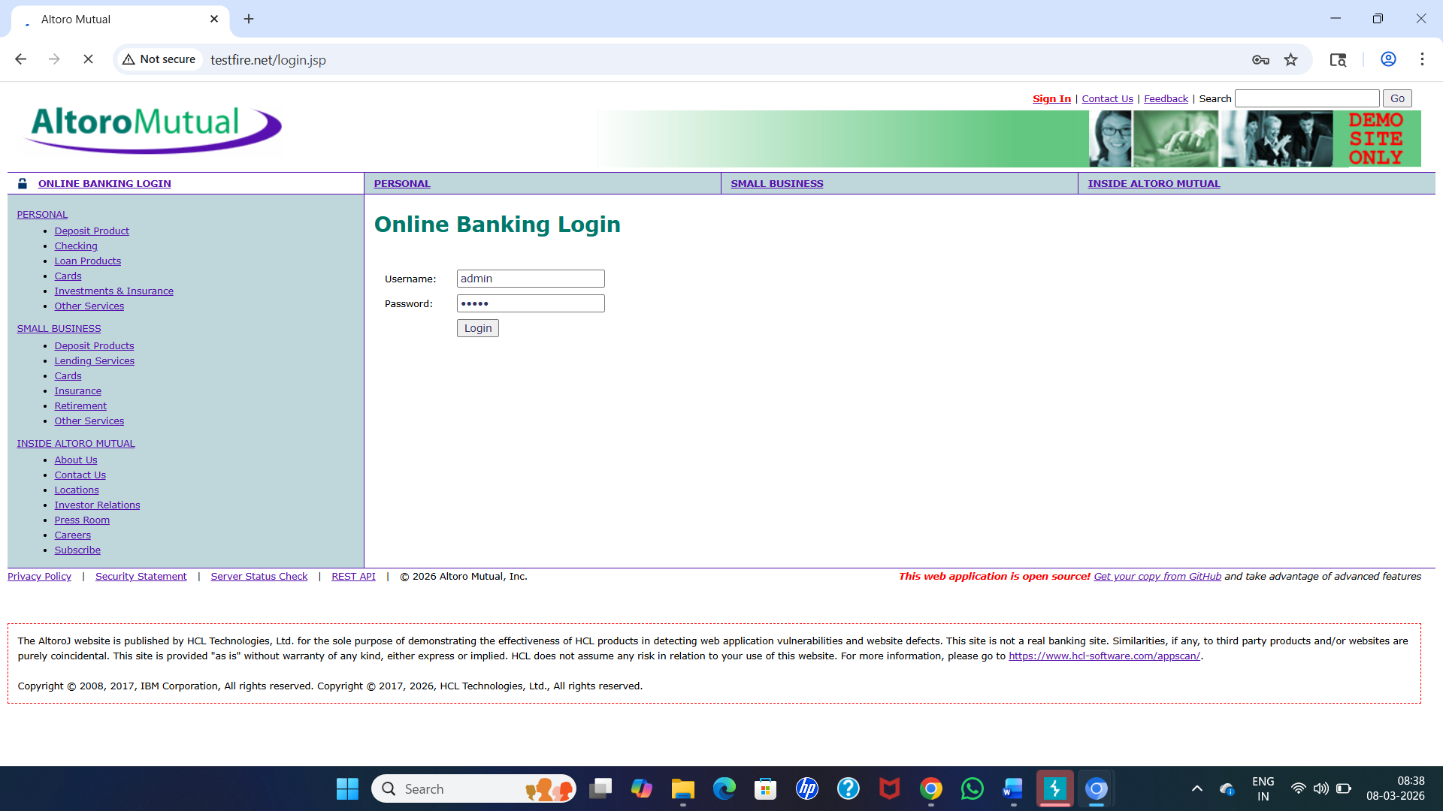

Step 3: View HTTP History

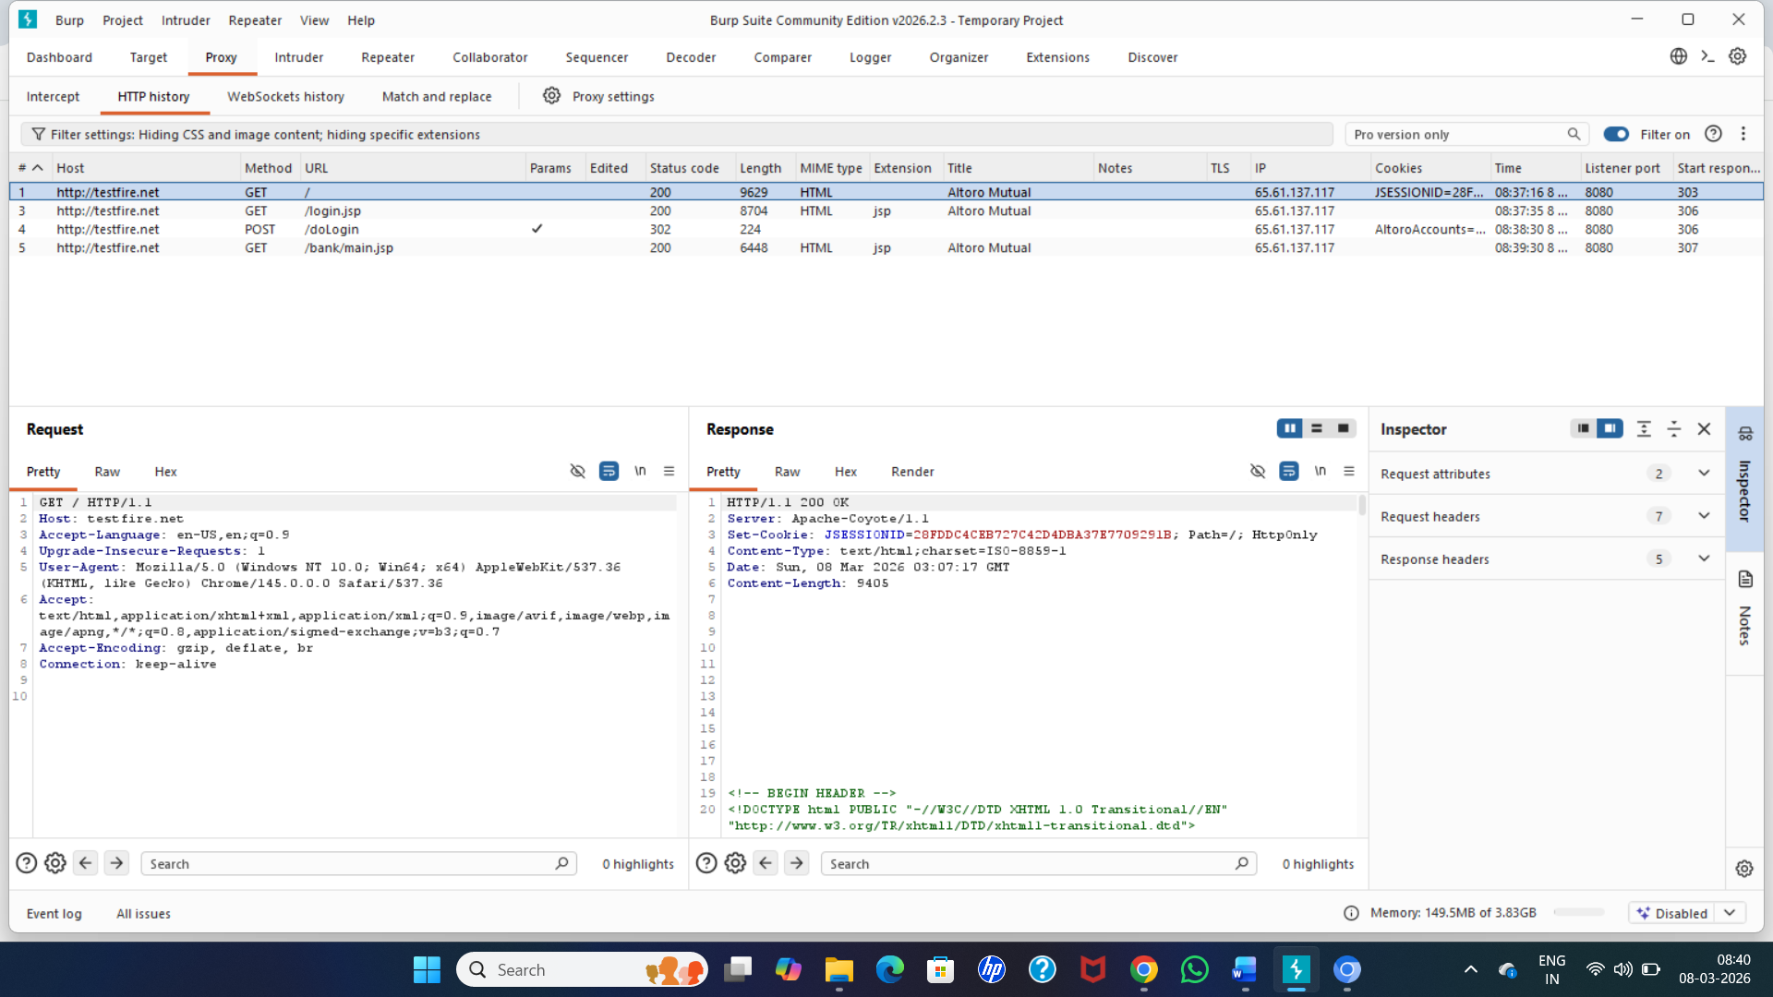

Recommendations:
• Ensure that all sensitive cookies are configured with the Secure attribute so that they are transmitted only over encrypted HTTPS connections. This prevents cookies from being exposed through insecure HTTP communication.
• Enforce HTTPS across the entire application and redirect all HTTP requests to HTTPS to ensure that sensitive data, including cookies and session identifiers, are always transmitted securely.
• Implement additional cookie security attributes such as HttpOnly and SameSite. The HttpOnly attribute prevents client-side scripts from accessing cookies, while SameSite helps protect against cross-site request forgery (CSRF) attacks.
• Regularly review and audit cookie configurations and server settings to ensure that security best practices are consistently followed across the application.
• Use secure session management practices, including strong session identifiers and appropriate session expiration policies, to reduce the risk of session hijacking and unauthorized access.

3. Vulnerability Name: Use of Obsolete Function
CWE: CWE-447
OWASP Category: A03:2025 Software Supply Chain Failures
Description
This vulnerability occurs when a web application uses outdated or obsolete functions, libraries, or APIs that are no longer considered secure or supported. These deprecated functions may contain known security weaknesses or lack modern security protections.
Developers sometimes continue to use older functions because they were part of legacy code or outdated third-party libraries. However, such functions may expose the application to vulnerabilities such as improper input handling, weak cryptographic mechanisms, or insecure data processing.
Attackers can exploit these weaknesses to bypass security controls, manipulate application behavior, or gain unauthorized access to sensitive data. As software dependencies evolve, it becomes important for organizations to regularly update their code and remove deprecated functions that may introduce security risks.

Business Impact
The use of obsolete or deprecated functions can expose applications to known vulnerabilities that attackers may easily exploit. Since these weaknesses are often publicly documented, attackers can leverage existing exploit techniques to compromise the system.
If exploited, attackers may gain unauthorized access to sensitive information, disrupt application functionality, or compromise the integrity of the system. In applications handling financial, personal, or confidential data, this may result in data breaches, financial losses, or regulatory compliance issues.
Additionally, continued reliance on outdated software components may increase maintenance costs and reduce the overall reliability and security of the application.

Step 1: Login using the credentials

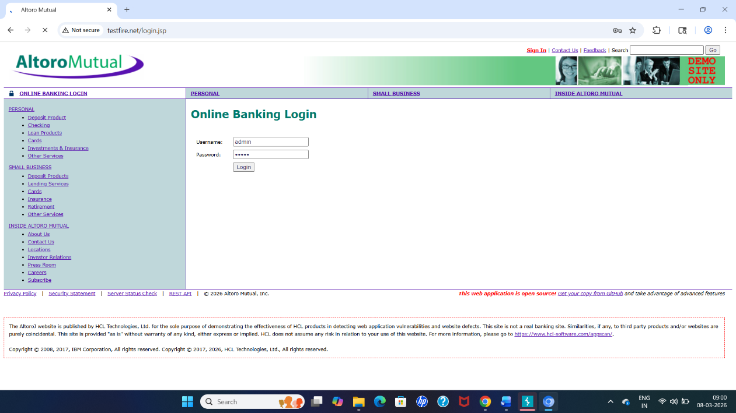

Step 2: Intercepted HTTP requests in Burp Suite
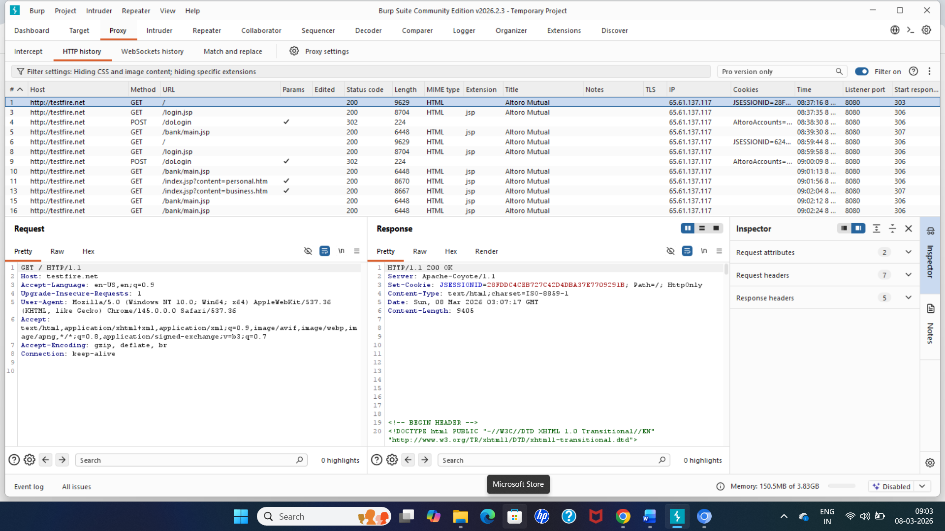

Step 3: Evidence showing outdated library or obselete function
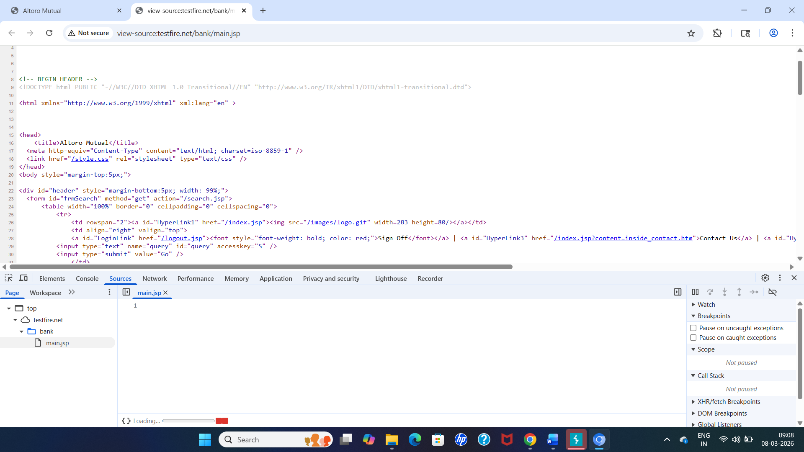

Recommendations:
• Ensure that all obsolete or deprecated functions are identified and replaced with modern and secure alternatives. Developers should regularly review the application code to remove outdated APIs or libraries that may introduce security risks.
• Maintain an updated software dependency management process. Regularly update third-party libraries, frameworks, and components to the latest stable versions that include security patches and improvements.
• Implement secure coding practices and follow industry standards when developing or maintaining applications. Developers should avoid using functions that are no longer supported or recommended.
• Perform regular security assessments and code reviews to detect the use of obsolete functions or outdated components within the application.
• Use automated dependency scanning tools to identify vulnerable or outdated libraries in the software supply chain and apply updates or patches promptly to reduce potential security risks.

4. Vulnerability Name: Not Using a Random IV with CBC Mode
CWE: CWE-329
OWASP Category: A04:2025 Cryptographic Failures
Description:
This vulnerability occurs when an application uses Cipher Block Chaining (CBC) mode for encryption without generating a random Initialization Vector (IV) for each encryption operation. The IV is used to ensure that identical plaintext values produce different ciphertext outputs during encryption. When a static, predictable, or reused IV is used instead of a random one, it weakens the security of the encryption process. As a result, attackers may be able to identify patterns in encrypted data or exploit cryptographic weaknesses to gain insights into the original plaintext. This improper implementation reduces the effectiveness of the encryption mechanism and may expose sensitive information to potential attacks.
Business Impact:
If an application does not use a random IV with CBC mode, attackers may analyze encrypted data patterns and potentially recover sensitive information through cryptographic attacks. This can compromise the confidentiality of important data such as user credentials, financial information, or personal records. In systems that process sensitive transactions or confidential business data, this weakness could lead to unauthorized data disclosure, financial loss, regulatory compliance issues, and reputational damage to the organization.

Steps to Reproduce:
Step 1: Login using the credentials



Step 2: HTTP Response captured

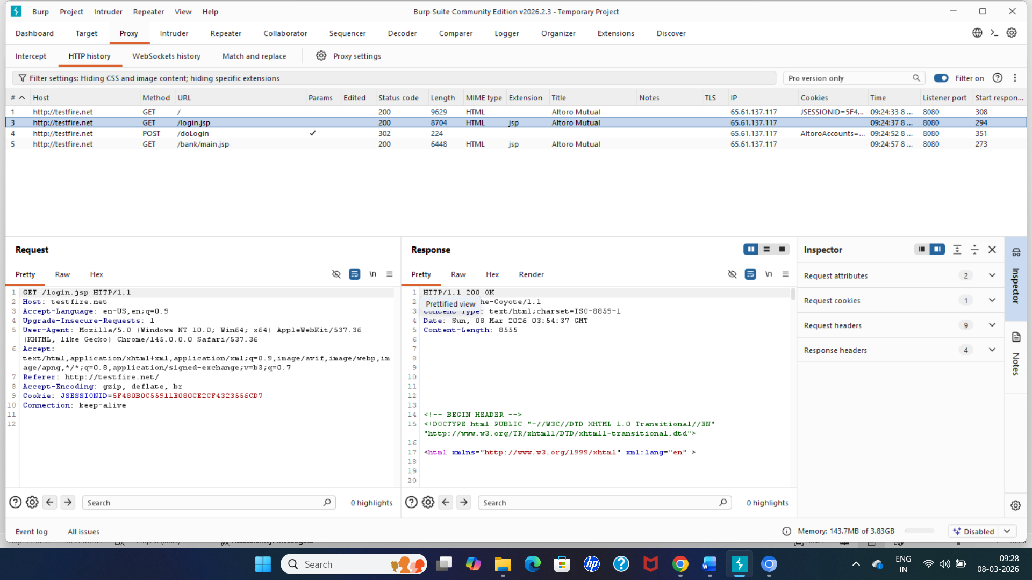

Step 3: Repeated encrypted reponse
- Logout from the website.
- Login again with the same credentials.
- Capture the response again in Burp Suite HTTP History.
If the encrypted output remains the same each time, it indicates that the Initialization Vector (IV) is not random.

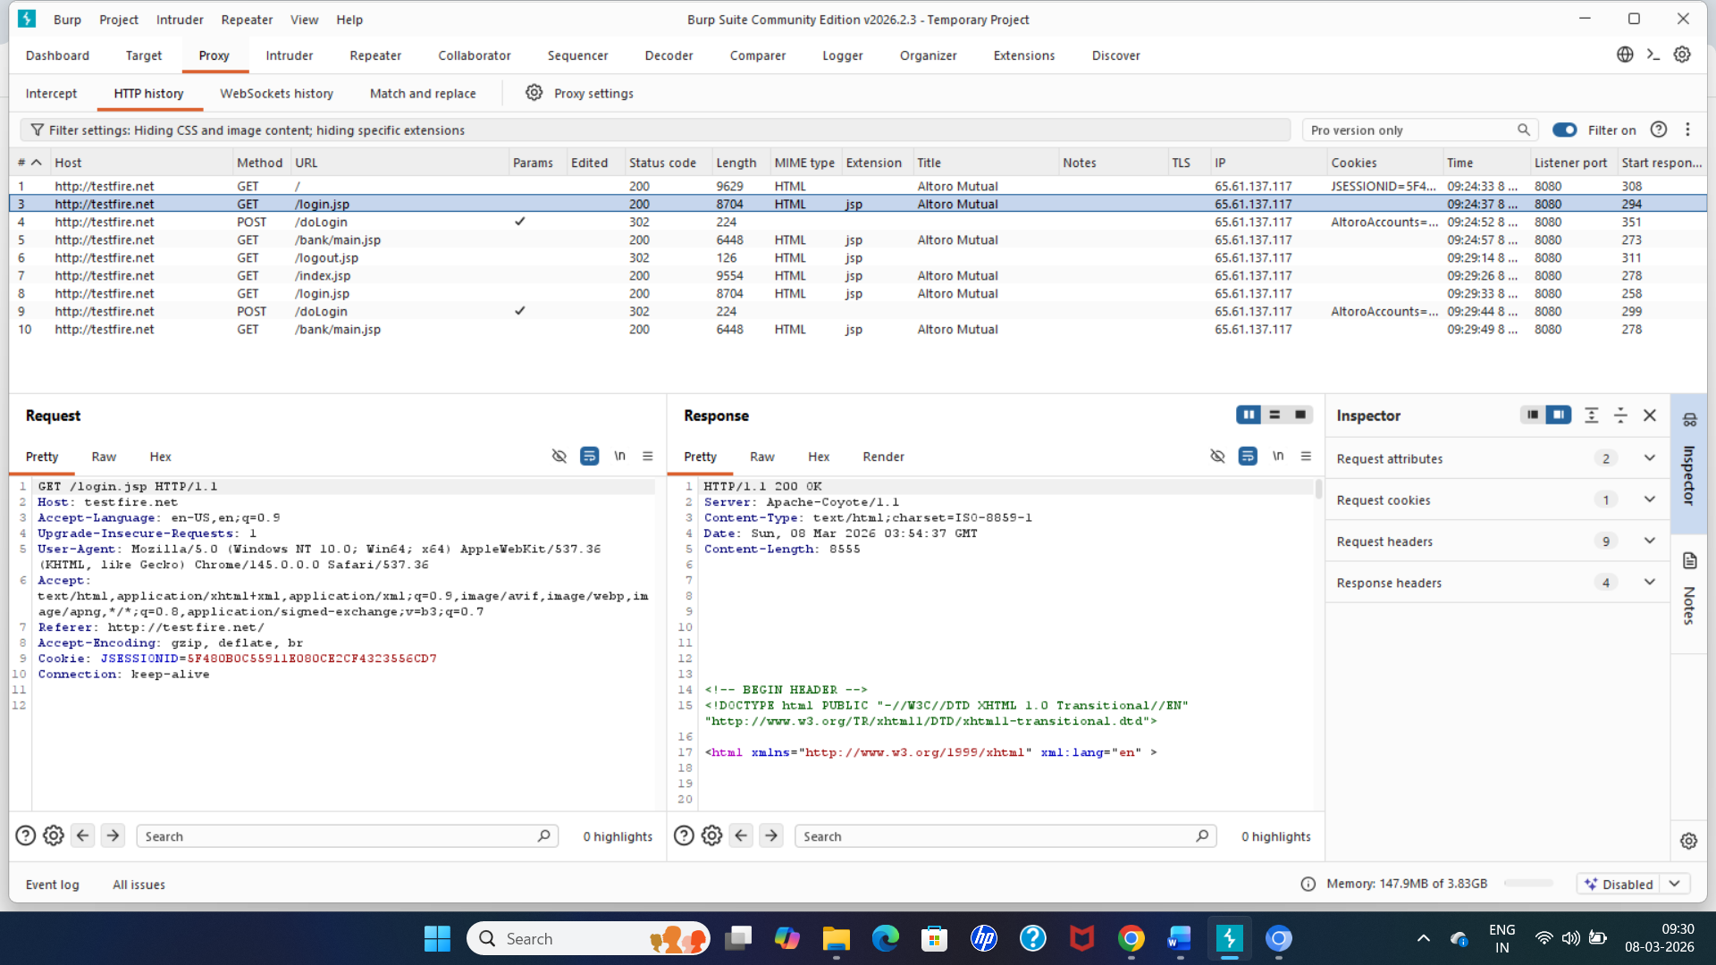

5. Vulnerability Name: XML Injection (aka Blind XPath Injection)
CWE: CWE-19
OWASP Category: A05:2025 Injection

Description
XML Injection, also known as Blind XPath Injection, occurs when a web application processes user input directly within XML queries without proper validation or sanitization. Applications that use XML documents or XPath queries to retrieve or manipulate data may become vulnerable when user-supplied input is embedded into these queries. Attackers can manipulate the input by inserting malicious XPath expressions that alter the logic of the query. Because the application does not properly validate the input, these injected expressions may allow attackers to bypass authentication mechanisms, retrieve unauthorized data, or manipulate the structure of XML queries. In blind XPath injection scenarios, attackers may not see direct query results but can infer information based on differences in application responses.

Business Impact
If XML Injection vulnerabilities are exploited, attackers may gain unauthorized access to sensitive information stored in XML databases or backend systems. In authentication systems that rely on XML queries, attackers could bypass login controls and access protected areas of the application without valid credentials. This may lead to exposure of confidential user data, financial records, or internal system information. Successful exploitation can also allow attackers to manipulate application behavior or extract data through repeated queries. Such incidents can result in data breaches, financial loss, regulatory compliance violations, and damage to the organization’s reputation.
Steps to reproduce:
Step 1: Login using the credentials


Step 2: Login request intercepted in Burp Suite

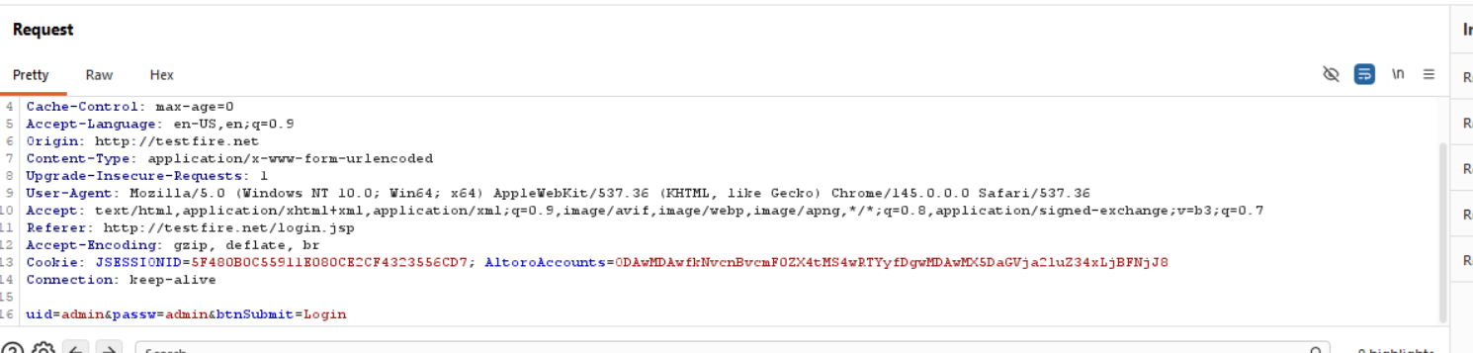
Change the admin to ‘1
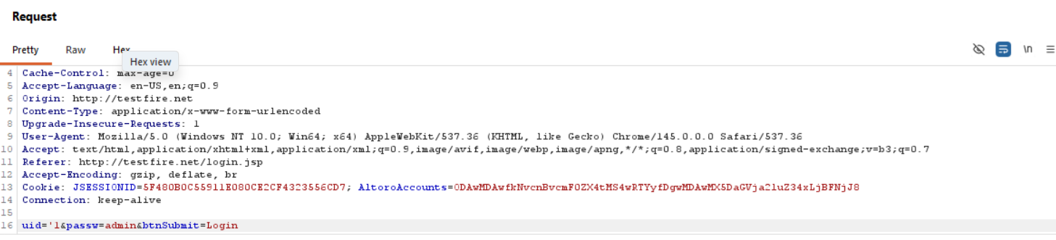
Recommendations:
• Validate and sanitize all user inputs before processing them in XML queries or XPath expressions. Proper input validation helps prevent attackers from injecting malicious XPath commands into the application.
• Implement parameterized XPath queries or secure XML parsing techniques to ensure that user-supplied input is treated as data rather than executable query logic.
• Apply input filtering and encoding mechanisms to remove or escape special characters such as quotes, logical operators, and XPath syntax that may be used in injection attacks.
• Use strong authentication and authorization mechanisms to prevent unauthorized users from accessing sensitive XML-based resources or backend systems.
• Conduct regular security testing and code reviews to identify and fix XML or XPath injection vulnerabilities during development and maintenance of the application.

6.Vulnerability Name: Unprotected Primary Channel
CWE: CWE-419
OWASP Category: A06:2025 Insecure Design

Description
This vulnerability occurs when a web application transmits sensitive information through an unprotected or insecure communication channel. The primary communication channel between the client and the server should be protected using secure protocols such as HTTPS with proper encryption. When the application uses an insecure protocol such as HTTP or fails to enforce encryption, the transmitted data may be exposed to attackers who are monitoring the network traffic. Sensitive information such as login credentials, session tokens, personal data, or financial information can be intercepted during transmission. Without proper encryption and protection mechanisms, attackers may perform eavesdropping, data manipulation, or man-in-the-middle attacks to compromise the confidentiality and integrity of the communication.

Business Impact
If the primary communication channel is not protected, attackers may intercept sensitive data transmitted between users and the application. This can allow attackers to capture login credentials, session identifiers, or confidential business information. In financial or banking applications, this could lead to unauthorized account access, fraudulent transactions, or exposure of sensitive customer data. Such attacks may result in data breaches, financial loss, legal liabilities, and reputational damage to the organization. Additionally, compromised communication channels may allow attackers to manipulate transmitted data, which can further impact the integrity and reliability of the system.
Steps to reproduce:
Step 1: Login using the credentials


Step 2: Observe the communication protocol

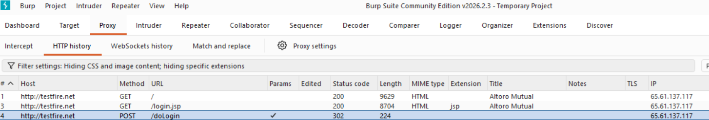

The request is being sent using
http://testfire.net
instead of
https://testfire.net

This means the communication is not encrypted.

Recommendations:
• Ensure that all communication between the client and server is secured using HTTPS with strong TLS encryption. This helps protect sensitive data such as login credentials and session identifiers from being intercepted during transmission.
• Configure the web server to automatically redirect all HTTP requests to HTTPS so that users cannot access the application through an insecure communication channel.
• Implement secure transport layer configurations by disabling outdated and insecure protocols and enabling only strong encryption standards.
• Avoid transmitting sensitive information over unencrypted channels and ensure that all authentication, session management, and sensitive operations occur over secure connections.
• Perform regular security assessments and network monitoring to detect insecure communication channels and ensure that all data transmitted between the client and server remains protected.

7.Vulnerability Name: Improper Validation of Certificate with Host Mismatch
CWE: CWE-299
OWASP Category: A07:2025 Authentication Failures
Description
This vulnerability occurs when an application fails to properly verify whether the hostname in a server’s SSL/TLS certificate matches the hostname of the server it is communicating with. During secure communication over HTTPS, the client verifies the server’s certificate to ensure that it was issued by a trusted certificate authority and that the certificate belongs to the correct domain. If the application does not validate the hostname correctly, it may accept certificates issued for different domains. As a result, attackers can present a valid certificate for another domain and impersonate the legitimate server. This improper certificate validation weakens the authentication mechanism and allows malicious systems to appear trustworthy to the client application.

Business Impact
If an application accepts certificates with a hostname mismatch, attackers may perform man-in-the-middle (MITM) attacks by intercepting communication between the user and the server. The attacker can present a different certificate and still establish a connection with the client. This allows the attacker to monitor, capture, or modify sensitive information such as login credentials, financial data, and personal information. In critical systems such as banking or enterprise applications, this weakness may lead to unauthorized access, data manipulation, financial fraud, and loss of user trust. It may also result in regulatory violations and reputational damage for the organization.

Steps to reproduce:
Step 1: Login using the credentials


Step 2: Browser certificate window
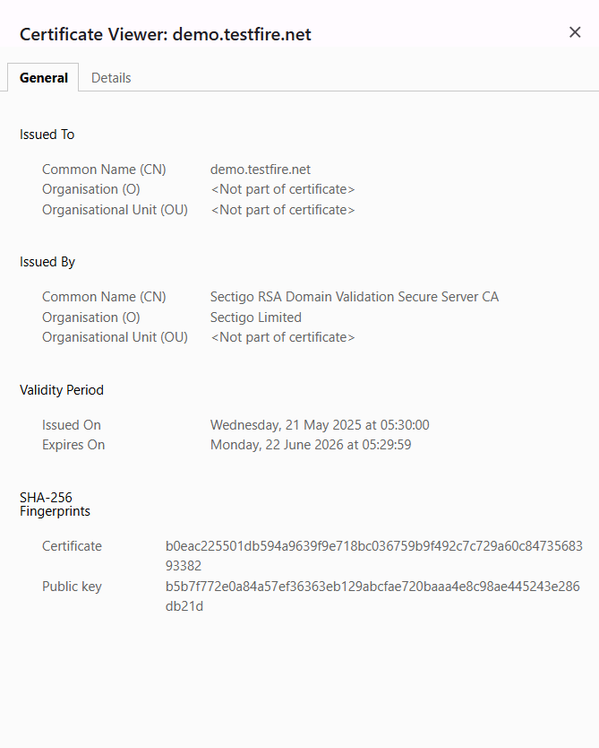

Step 3:Identify the Vulnerability
If the application accepts the connection even when the hostname does not match the certificate, it indicates that the application fails to properly validate the server identity.
This confirms the vulnerability:
Improper Validation of Certificate with Host Mismatch (CWE-299).
Because of this issue, attackers may use a valid certificate issued for another domain and impersonate the legitimate server.

Recommendations:
- Ensure that the application strictly validates the hostname in the server’s SSL/TLS certificate to match the domain being accessed. This prevents attackers from presenting certificates issued for other domains.
- Use certificates issued by trusted Certificate Authorities (CAs) and configure the application to reject self-signed or untrusted certificates in production environments.
- Verify the full certificate chain, including intermediate certificates, and ensure that no expired or revoked certificates are accepted.
- Consider implementing certificate pinning for high-security applications to restrict clients to specific certificates or public keys, preventing man-in-the-middle attacks.
- Enable modern TLS versions (TLS 1.2 or TLS 1.3) and disable insecure or outdated protocols to strengthen secure communications.
- Log failed certificate validation attempts and review logs regularly to detect potential attacks or misconfigurations.
- Avoid bypassing SSL/TLS verification in development or test environments, and include certificate validation checks in automated testing and CI/CD pipelines.

8.Vulnerability Name: Improperly Controlled Modification of Dynamically-Determined Object Attributes
CWE: CWE-915
OWASP Category: A08:2025 Software or Data Integrity Failures
Description
This vulnerability occurs when an application allows users to modify object attributes dynamically without enforcing proper authorization or validation. Applications often represent objects, such as user accounts, invoices, or system configurations, with multiple attributes that can be updated through forms, API requests, or JSON payloads. If the application relies on client-side controls or assumes the user cannot tamper with these attributes, attackers may manipulate them to gain unauthorized access, escalate privileges, or modify sensitive data. Failure to implement strict server-side validation for dynamically-determined object attributes compromises the integrity of the application and can lead to unintended behaviour.

Business Impact
If exploited, this vulnerability can allow attackers to manipulate sensitive data, escalate privileges, or bypass critical business logic controls. For example, an attacker may modify account roles to gain administrative access, alter financial records, or change system configurations without authorization. This can result in data corruption, unauthorized access, financial losses, regulatory violations, and a loss of user trust. In critical systems such as banking, enterprise, or healthcare applications, the integrity of the data and application functionality can be severely impacted, posing significant operational and reputational risks.

Steps to reproduce:
Steps to reproduce:
Step 1: Login using the credentials



Step 2: Go to edit user page
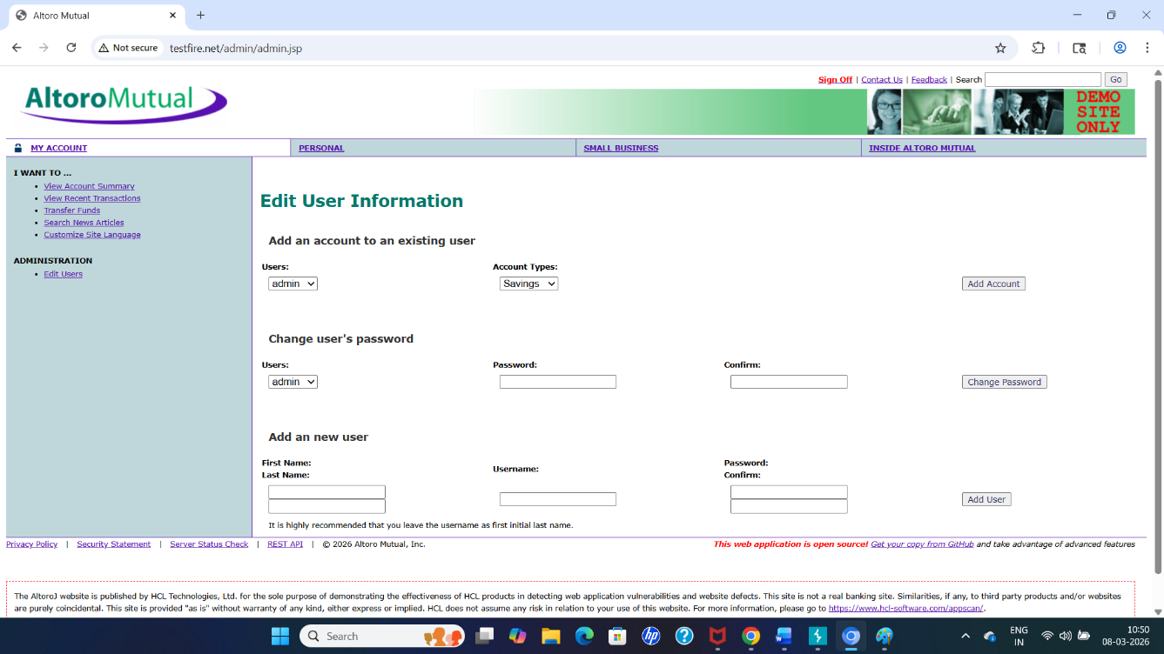
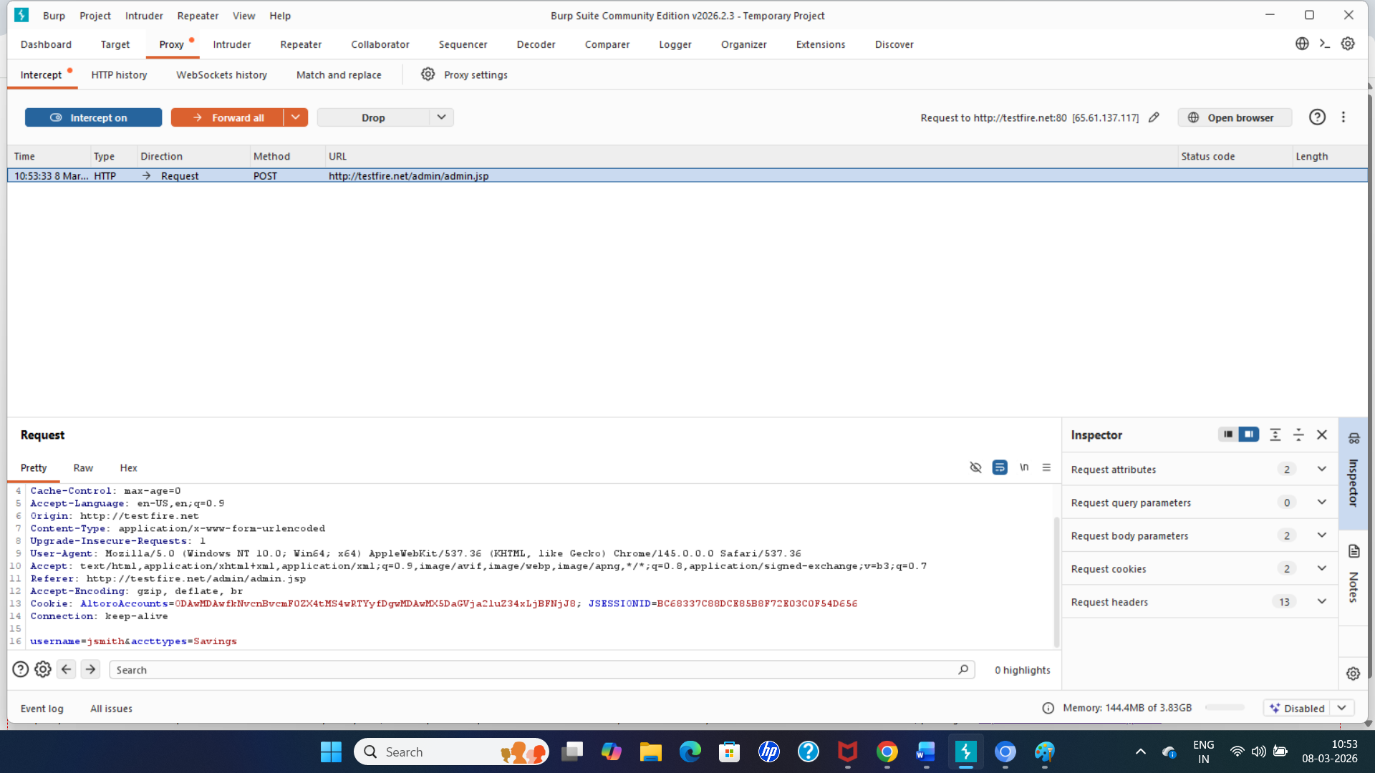
Step 3: Modify attribute
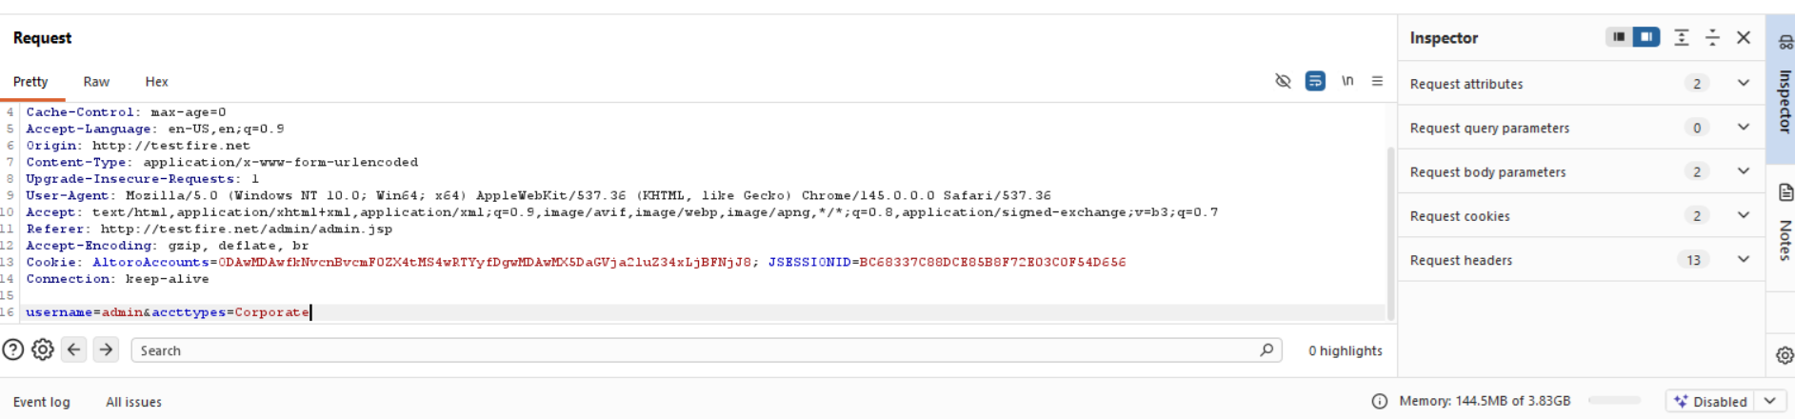

username=jsmith&accttypes=Corporate

Step 3 — Check the Website
Go back to the browser and refresh the page.
Check if:
- The account type changed
- The account data changed
- You can access another account type
If the application accepts the change without proper validation, it shows that object attributes can be manipulated.

9.Vulnerability Name: Omission of Security-relevant Information
CWE: CWE-223
OWASP Category: A09:2025 Security Logging & Alerting Failures
Description:
This vulnerability occurs when an application fails to properly log or alert on security-relevant events such as failed login attempts, unauthorized access, configuration changes, or suspicious activities. Proper logging and alerting are essential for detecting, investigating, and responding to potential attacks. When security-relevant information is omitted or inadequately recorded, administrators and security teams may remain unaware of ongoing malicious activities. Attackers can exploit this gap to operate undetected, escalating privileges, exfiltrating data, or compromising systems without triggering alerts. The lack of detailed logs—including timestamps, user identifiers, and source information—further weakens an organization’s ability to perform forensic analysis and respond effectively to incidents.
Business Impact:
If critical security events are not logged or alerted, organizations risk delayed detection of attacks, prolonged system compromise, and increased damage from breaches. This can result in loss of sensitive data, regulatory non-compliance, financial losses, reputational damage, and erosion of customer trust. In high-risk environments such as banking, healthcare, or enterprise systems, this weakness significantly undermines security monitoring and incident response capabilities, allowing attackers to exploit systems without detection.
Steps to reproduce:
Step 1: Login using the credentials
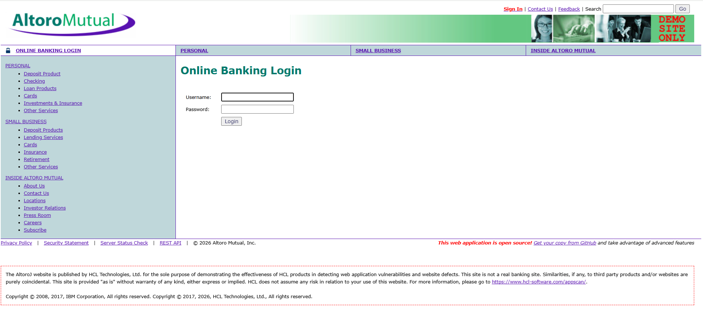
Step 2: Perform invalid login attempts
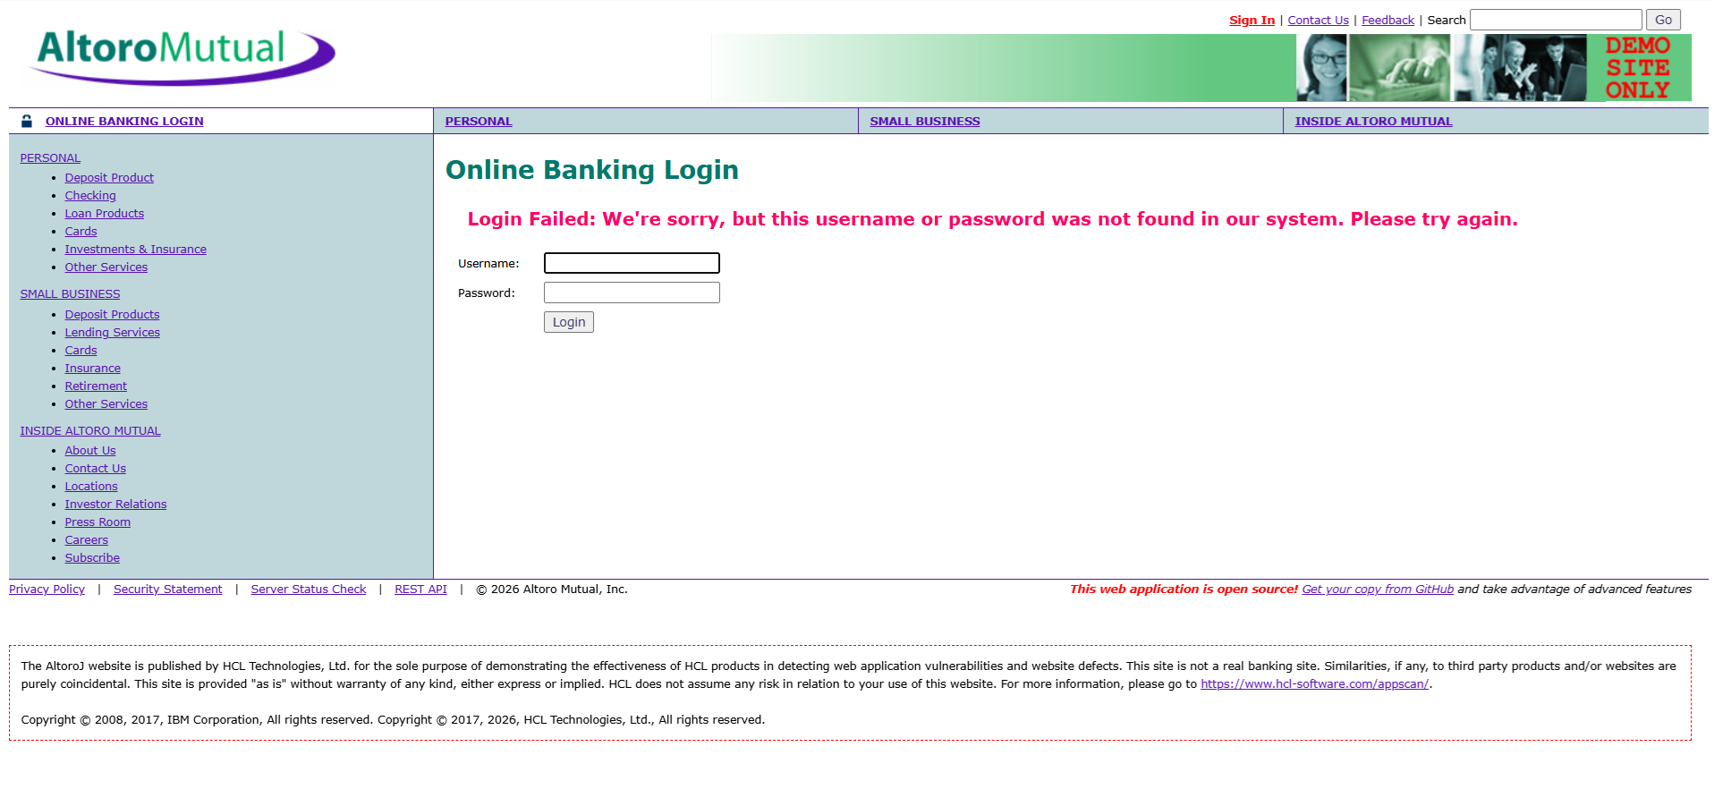Step 3: Evidence showing repeated suspicious activity without detection.
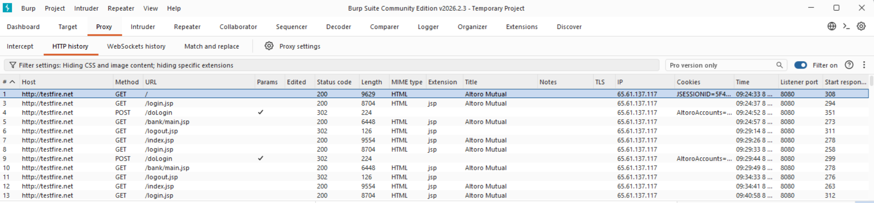
Attempt several suspicious actions such as:
- Multiple failed logins
- Accessing restricted pages directly
- Repeating authentication requests
If the application does not log or alert these activities, it indicates the vulnerability Omission of Security-relevant Information.
Step 4: Confirm the Vulnerability
The application is considered vulnerable if:
- Failed login attempts are not logged.
- No alerts are generated for suspicious activity.
- Accounts are not temporarily locked after repeated failures.
- Security monitoring mechanisms are absent.
This confirms the presence of Omission of Security-relevant Information (CWE-223).

Recommendations:
• Implement comprehensive logging mechanisms to record all security-relevant events such as authentication attempts, account lockouts, privilege changes, configuration modifications, and access to sensitive resources.
• Ensure that logs capture sufficient details including user identifiers, timestamps, source IP addresses, request information, and the outcome of the event to support effective monitoring and forensic investigations.
• Configure real-time monitoring and alerting systems to notify administrators or security teams when suspicious activities occur, such as multiple failed login attempts or unauthorized access attempts.
• Protect log integrity by restricting access to authorized personnel only and by storing logs securely to prevent tampering, deletion, or unauthorized modification.
• Maintain proper log retention policies and regularly review log data to detect anomalies, investigate incidents, and support compliance with security and regulatory requirements.

10.Vulnerability Name: Declaration of Throws for Generic Exception
CWE: CWE-397
OWASP Category: A10:2025 Mishandling of Exceptional Conditions
Description
This vulnerability occurs when an application declares or throws a generic exception such as Exception, Throwable, or other broad exception types instead of using specific exception classes. When developers use generic exceptions, the application may fail to properly handle different types of errors individually. This practice reduces the effectiveness of error handling because the system cannot distinguish between different failure conditions such as authentication errors, database failures, or input validation issues. As a result, important details about the cause of the error may be lost or improperly managed, and in some cases the application may expose unnecessary internal information through error messages. Improper exception handling can weaken application reliability and create opportunities for attackers to exploit unexpected behaviors in the system.

Business Impact
Improper use of generic exceptions can lead to poor error management, system instability, and information disclosure. Attackers may exploit improperly handled exceptions to trigger unexpected system behavior, identify weaknesses in the application logic, or obtain sensitive information such as system paths, database queries, or stack traces. In production environments, this weakness can reduce the organization’s ability to detect and respond to system failures effectively. For businesses handling sensitive data or financial transactions, improper exception handling may lead to service disruptions, potential data exposure, operational risks, and loss of customer trust.

Steps to reproduce:
Step 1: Login using the credentials


Step 2 – Send Malicious or Unexpected Input
To trigger generic exceptions:
Enter invalid or unusual values in input fields.

Step 3 – Verify Lack of Proper Error Handling
Check for key indicators:
- The error message exposes internal system information.
- Different types of errors (input validation, missing data, database errors) are all reported as generic exceptions.
- Application does not gracefully handle or log the error properly.
If these occur, it confirms the vulnerability Declaration of Throws for Generic Exception (CWE-397).

Recommendations:
• Use specific exception classes instead of generic exceptions such as Exception or Throwable. Developers should handle different error conditions using appropriate exception types (e.g., IOException, SQLException, AuthenticationException) so that errors can be properly identified and managed.
• Implement structured exception handling in the application code. Each exception should be handled with dedicated try-catch blocks that provide controlled responses and prevent the application from exposing internal details.
• Avoid displaying detailed error messages or stack traces to end users. Instead, show user-friendly error messages while logging the detailed technical information securely on the server for debugging and incident analysis.
• Maintain secure error logging mechanisms to record exception details such as timestamps, error type, and request context. Logs should be accessible only to authorized administrators and protected from unauthorized access or modification.
• Conduct regular code reviews and security testing to identify improper exception handling practices. Developers should follow secure coding standards and ensure that generic exception declarations are replaced with precise and meaningful exception handling mechanisms.

STAGE – 2

Overview of a Nessus Scan
A Nessus vulnerability scan is a structured process used to discover security weaknesses in computer systems and networks. The process generally follows several important stages.
1. Preparation
The first step is planning the scan. Security administrators identify the purpose and scope of the assessment. This involves deciding which systems, networks, or devices will be analyzed and what types of vulnerabilities need to be detected. At this stage, it is also necessary to ensure that the scanning team has proper authorization and access permissions to perform the scan.
2. Configuration
After planning, the scanning parameters are configured. A scan policy is created to determine how the scan should operate. This policy may include vulnerability categories, authentication details, scanning schedules, and other technical settings. The user also specifies the target assets, such as IP addresses, hostnames, or network ranges.
3. Scanning Process
Once configuration is completed, the scan is launched. Nessus begins examining the selected systems using its built-in vulnerability plugins and security checks. It inspects services, software versions, and system configurations to locate possible weaknesses.
4. Vulnerability Detection
During the scanning stage, Nessus identifies issues such as outdated software, configuration errors, open ports, weak security settings, and missing patches. Each vulnerability is classified based on its severity level (for example: low, medium, high, or critical) so that organizations can determine which problems should be resolved first.
5. Report Generation
After the scan is completed, Nessus produces comprehensive reports that describe all detected vulnerabilities. These reports usually include the vulnerability description, risk level, evidence, and recommended solutions. Reports can be exported in formats such as PDF, HTML, or CSV.
6. Remediation
The IT or security team carefully reviews the scan results and begins addressing the vulnerabilities. Corrective measures may include installing patches, updating software, adjusting configurations, or implementing stronger security controls.
7. Follow-Up Activities
Organizations normally perform regular vulnerability scans to maintain security over time. Continuous scanning helps detect newly emerging threats and confirms whether previously discovered vulnerabilities have been resolved. Nessus may also be integrated with other security tools to automate vulnerability management.

8. Compliance Verification
If compliance policies are included in the scan configuration, Nessus can check whether systems comply with industry regulations or security standards.
9. Documentation
All scan reports, remediation steps, and compliance results should be documented. Proper documentation helps organizations maintain records for auditing and security monitoring purposes.
10. User Training
Security professionals and IT staff should receive proper training in using Nessus and understanding scan results so that they can respond effectively to detected vulnerabilities. Overall, Nessus scanning plays a vital role in proactive cybersecurity by identifying weaknesses before they can be exploited by attackers.

Nessus is one of the most widely used vulnerability scanning tools in the cybersecurity field. It assists organizations in identifying security flaws in systems and networks so that they can take preventive action against potential cyberattacks.
1. Vulnerability Assessment
The primary function of Nessus is to conduct vulnerability assessments. It scans systems to identify security weaknesses such as missing updates, weak passwords, misconfigurations, and other potential threats.
2. Network Device Scanning
Nessus is capable of scanning different types of network devices including servers, routers, switches, firewalls, and workstations. It analyzes running services, open ports, and software versions on these devices.
3. Plugin-Based Architecture
One of the major strengths of Nessus is its plugin system. These plugins enable the scanner to detect a wide range of vulnerabilities. The plugin database is regularly updated to include checks for newly discovered security threats.
4. Compliance Assessment
Nessus can also evaluate systems against security standards and regulatory frameworks. This helps organizations ensure their infrastructure complies with industry guidelines and best practices.
5. Customizable Scans
Users can customize scans based on their specific requirements. They can define scan policies, choose vulnerability categories, and specify target systems, making the scanning process flexible and adaptable.
6. Detailed Reporting
Nessus produces detailed vulnerability reports that provide severity levels, explanations of vulnerabilities, and recommended remediation steps. These reports assist security teams in prioritizing risk mitigation.
7. Regular Security Monitoring
Many organizations perform Nessus scans periodically to maintain strong security. Regular scanning helps organizations stay prepared against new vulnerabilities and evolving cyber threats.
8. Integration with Security Tools
Nessus can be integrated with other cybersecurity platforms and tools, allowing organizations to automate scanning processes and improve vulnerability management workflows.
9. Licensing Options
Nessus is available in both free and commercial versions. The free version provides limited functionality, while paid versions offer advanced features, technical support, and enhanced scanning capabilities.
10. Easy-to-Use Interface
Nessus includes a web-based user interface that simplifies the scanning process. Even users with limited cybersecurity experience can navigate the tool and interpret results effectively.
Conclusion
Nessus is an essential tool for organizations aiming to strengthen their cybersecurity defenses. While it effectively detects vulnerabilities, the responsibility for fixing these issues lies with the organization's IT and security teams.

S.No | Vulnerability Name | Severity | Plugins
1. | SSL (Multiple Issues) | Info | SSL Certificate Information
2. | TLS (Multiple Issues) | Info | TLS Version Detection
3. | Service Detection | Info | Network Service Detection
4. | IETF MD5 (Multiple Issues) | Info | MD5 Signature Detection
5. | TLS (Multiple Issues) | Info | TLS Security Check
6. | Nessus SYN Scanner | Info | Port Scanner
7. | Additional DNS Hostnames | Info | DNS Hostname Detection
8. | Nessus Scan Information | Info | Nessus Scan Info Plugin
9. | OS Fingerprints Detected | Info | OS Fingerprinting
10. | OS Identification | Info | Operating System Detection
11. | Remote Services Not Using Encryption | Info | Service Encryption Check
12. | TCP/IP Timestamps Supported | Info | TCP/IP Timestamp Detection
13. | TLS ALPN Supported Protocol | Info | TLS Protocol Detection
14. | Traceroute Information | Info | Network Route Detection

Target Website: testfire.net
Target IP Address: 54.83.41.36

1. VULNERABILITY NAME: SSL (Multiple Issues)
SEVERITY: Info
PLUGIN: SSL Certificate Information
PORT: N/A
DESCRIPTION:
This plugin gathers detailed information about the Secure Sockets Layer (SSL) certificate installed on the target server. It analyzes certificate properties such as the certificate issuer, validity period, encryption algorithm, key length, and certificate chain. The purpose of this check is to verify whether the SSL certificate used by the server is valid and properly configured. Although the result is informational, it provides useful insight into the encryption mechanism protecting communication between clients and the server. Incorrect or outdated SSL configurations can lead to potential security weaknesses.
SOLUTION:
• Ensure that the SSL certificate is issued by a trusted Certificate Authority (CA).
• Regularly monitor the certificate validity period and renew certificates before expiration.
• Use modern cryptographic algorithms and strong key lengths for better security.
• Disable outdated SSL protocols such as SSLv2 and SSLv3 and replace them with stronger protocols like TLS 1.2 or TLS 1.3.
BUSINESS IMPACT:
Improper SSL configuration may reduce user trust and compromise secure communication. If certificates expire or use weak encryption algorithms, attackers may exploit these weaknesses to intercept sensitive information transmitted between the server and its users.

2. VULNERABILITY NAME: TLS (Multiple Issues)
SEVERITY: Info
PLUGIN: TLS Version Detection
PORT: N/A
DESCRIPTION:
This plugin detects the versions of Transport Layer Security (TLS) supported by the target system. TLS is responsible for securing data transmitted between clients and servers across a network. The plugin identifies whether the server supports older or newer versions of TLS and provides information about the encryption capabilities of the server. While this finding is informational, it helps administrators understand whether outdated protocols are enabled, which could expose the system to known vulnerabilities.
SOLUTION:
• Disable outdated TLS versions such as TLS 1.0 and TLS 1.1.
• Configure the server to support secure protocols like TLS 1.2 and TLS 1.3.
• Regularly review server encryption settings to ensure compliance with modern security standards.
BUSINESS IMPACT:
Supporting outdated TLS versions may expose the system to cryptographic attacks and data interception risks. Attackers could potentially exploit these vulnerabilities to compromise sensitive data transmitted through encrypted channels.

3. VULNERABILITY NAME: Service Detection
SEVERITY: Info
PLUGIN: Network Service Detection
PORT: N/A
DESCRIPTION:
This plugin identifies the network services running on the target host by analyzing responses from open ports. It determines which applications or services are active, such as web servers, file transfer services, database servers, or remote access services. This information helps administrators understand the system’s network exposure and service configuration. Although the finding is informational, it provides valuable data for security monitoring and system management.
SOLUTION:
• Review all detected services and confirm whether they are required.
• Disable or remove unnecessary services to reduce potential attack surfaces.
• Use firewalls and access control mechanisms to restrict access to sensitive services.
BUSINESS IMPACT:
Unnecessary or poorly configured services may provide entry points for attackers. Even though this result is informational, exposed services can reveal system functionality and assist attackers in planning targeted attacks.

4. VULNERABILITY NAME: IETF MD5 (Multiple Issues)
SEVERITY: Info
PLUGIN: MD5 Signature Detection
PORT: N/A
DESCRIPTION:
This plugin detects the use of the MD5 hashing algorithm in certain cryptographic operations. MD5 was once widely used for generating message digests and verifying data integrity. However, it is now considered cryptographically weak because it is vulnerable to collision attacks, where two different inputs produce the same hash value. The presence of MD5 in a system does not necessarily indicate an active vulnerability but highlights a potential security weakness.
SOLUTION:
• Replace MD5 hashing with stronger algorithms such as SHA-256 or SHA-3.
• Update applications and cryptographic libraries that still rely on MD5.
• Follow modern cryptographic best practices for data integrity and authentication mechanisms.
BUSINESS IMPACT:
Using weak hashing algorithms may compromise data integrity and increase the risk of digital signature forgery or authentication bypass. Attackers may exploit such weaknesses to manipulate data or impersonate legitimate users.

5. VULNERABILITY NAME: TLS (Multiple Issues)
SEVERITY: Info
PLUGIN: TLS Security Check
PORT: N/A

DESCRIPTION:
This plugin evaluates the TLS configuration of the target host, including supported cipher suites, encryption algorithms, and protocol settings. The purpose of this check is to determine whether the server uses secure cryptographic configurations or allows weak encryption methods. Although the issue is informational, it provides insight into the strength of the server’s encryption mechanisms.
SOLUTION:
• Configure the server to use strong cipher suites and encryption algorithms.
• Disable weak or deprecated ciphers such as RC4 or DES.
• Follow recommended TLS security guidelines to ensure robust encryption.
BUSINESS IMPACT:
Weak TLS configurations may reduce the effectiveness of encrypted communication and expose data to potential interception or decryption attempts by attackers.

6. VULNERABILITY NAME: Nessus SYN Scanner
SEVERITY: Info
PLUGIN: Port Scanner
PORT: N/A
DESCRIPTION:
The Nessus SYN scanner identifies open TCP ports on the target system by sending SYN packets and analyzing the responses. This technique helps determine which network services are accessible on the host. The plugin is primarily used to discover active ports and services that may be exposed to the network.
SOLUTION:
• Review the list of open ports discovered during the scan.
• Close unnecessary ports through firewall configurations.
• Implement network access controls to restrict unauthorized access.
BUSINESS IMPACT:
Open ports provide information about available services and may serve as potential entry points for attackers. Reducing the number of exposed ports helps improve overall system security.

7. VULNERABILITY NAME: Additional DNS Hostnames
SEVERITY: Info
PLUGIN: DNS Hostname Detection
PORT: N/A
DESCRIPTION:
This plugin identifies additional DNS hostnames that are associated with the target IP address. These hostnames may represent subdomains, aliases, or services linked to the system. The detection helps administrators understand how the system is referenced within the network.
SOLUTION:
• Verify that all discovered DNS hostnames are valid and required.
• Remove outdated or unused DNS records.
• Monitor DNS configurations to prevent unauthorized changes.
BUSINESS IMPACT:
Exposure of unnecessary DNS hostnames may reveal information about the organization’s network infrastructure and internal systems.

8. VULNERABILITY NAME: Nessus Scan Information
SEVERITY: Info
PLUGIN: Nessus Scan Info Plugin
PORT: N/A
DESCRIPTION:
This plugin provides metadata related to the Nessus scan, including scan start time, duration, scanning policy, and scanning engine details. It does not represent a vulnerability but helps maintain accurate documentation of the scanning process.
SOLUTION:
• Maintain records of scan results for auditing and reporting purposes.
• Review scan configurations to ensure that the correct policies are applied.
BUSINESS IMPACT:
Proper scan documentation helps organizations maintain compliance records and track improvements in their security posture.

9. VULNERABILITY NAME: OS Fingerprints Detected
SEVERITY: Info
PLUGIN: OS Fingerprinting
PORT: N/A
DESCRIPTION:
The plugin attempts to identify the operating system running on the target host by analyzing network traffic patterns and system responses. OS fingerprinting provides an estimate of the system’s platform and version.
SOLUTION:
• Ensure that operating systems are regularly updated with security patches.
• Limit unnecessary system information exposure where possible.
BUSINESS IMPACT:
Knowledge of the operating system may allow attackers to identify system-specific vulnerabilities and exploit them.

10. VULNERABILITY NAME: OS Identification
SEVERITY: Info
PLUGIN: Operating System Detection
PORT: N/A
DESCRIPTION:
This plugin identifies the operating system installed on the target host by analyzing service banners and network responses. It helps administrators confirm system configurations and detect unknown devices on the network.
SOLUTION:
• Apply regular updates and security patches to the operating system.
• Implement network monitoring tools to detect unauthorized devices.
BUSINESS IMPACT:
Operating system information may assist attackers in identifying suitable exploits for the detected platform.

11. VULNERABILITY NAME: Remote Services Not Using Encryption
SEVERITY: Info
PLUGIN: Service Encryption Check
PORT: N/A
DESCRIPTION:
The scan detected remote services that transmit data without encryption. This means that communication between the client and server may occur in plain text, making it possible for attackers to intercept the transmitted data.
SOLUTION:
• Replace insecure protocols with secure alternatives such as HTTPS, SSH, or SFTP.
• Configure services to enforce encrypted communication.
BUSINESS IMPACT:
Unencrypted communication can expose sensitive information such as login credentials, confidential data, or internal communications.

12. VULNERABILITY NAME: TCP/IP Timestamps Supported
SEVERITY: Info
PLUGIN: TCP/IP Timestamp Detection
PORT: N/A
DESCRIPTION:
This plugin detects whether the system supports TCP timestamps. While timestamps improve network performance and reliability, they may also reveal system uptime information.
SOLUTION:
• Disable TCP timestamps if they are not required.
• Restrict unnecessary network information exposure.
BUSINESS IMPACT:
Attackers may use timestamp information for network reconnaissance and system analysis.

13. VULNERABILITY NAME: TLS ALPN Supported Protocol
SEVERITY: Info
PLUGIN: TLS Protocol Detection
PORT: N/A
DESCRIPTION:
The server supports Application Layer Protocol Negotiation (ALPN), which allows the client and server to select the application protocol during the TLS handshake process.
SOLUTION:
• Allow only secure and necessary application protocols.
• Regularly review TLS configuration settings.
BUSINESS IMPACT:
Improper protocol configuration may expose unnecessary services and increase potential attack surfaces.

14. VULNERABILITY NAME: Traceroute Information
SEVERITY: Info
PLUGIN: Network Route Detection
PORT: N/A
DESCRIPTION:
This plugin collects traceroute information that reveals the network path between the scanning system and the target host. It identifies intermediate routers and network devices.
SOLUTION:
• Implement network segmentation and firewall controls.
• Restrict exposure of internal network infrastructure where possible.
BUSINESS IMPACT:
Traceroute results may provide attackers with insights into network topology and infrastructure, assisting them in reconnaissance activities.

Stage – 3
Title:
Develop and implement adaptive access policies using contextual signals such as user identity, device health, geographic location, and application sensitivity.
Adaptive or context-aware access control is a fundamental component of a modern Zero Trust security model. Traditional security frameworks relied heavily on perimeter defenses and simple authentication mechanisms such as usernames and passwords. However, with the rapid growth of cloud computing, remote work environments, and mobile devices, these conventional approaches are no longer sufficient to protect sensitive resources. Context-aware access control introduces a dynamic security approach where each access request is evaluated based on multiple contextual parameters. Instead of granting access solely on the basis of credentials, the system continuously analyzes factors like who the user is, what device they are using, where they are connecting from, and how sensitive the requested application is. This layered analysis enables organizations to make more informed access decisions and significantly reduce the risk of unauthorized access.
The development of such an access control system begins with strong identity verification and identity management integration. Organizations typically rely on centralized Identity Providers (IdPs) such as Azure Active Directory, Okta, or similar platforms to authenticate users and manage their digital identities. When integrated with secure access solutions like Zero Trust Network Access (ZTNA) tools, the authentication process includes advanced mechanisms such as multi-factor authentication (MFA) to strengthen user verification. Once authentication is complete, the system retrieves additional identity attributes including the user’s role, department, and group membership. These attributes help administrators design detailed access policies tailored to the user’s responsibilities within the organization. For example, employees working in the finance department may be granted access to accounting platforms, while software developers may receive access to code repositories and development environments. By tying access rights directly to organizational roles, the risk of unnecessary privilege exposure is minimized.
While verifying the user’s identity is essential, it is equally important to evaluate the security posture of the device used for access. A legitimate user connecting from a compromised or insecure device can still pose a significant threat to the network. To mitigate this risk, organizations integrate device posture assessment tools such as Endpoint Detection and Response (EDR) systems and Mobile Device Management (MDM) platforms. These systems continuously monitor the device’s health and security configuration before allowing access to corporate resources. Factors such as whether the device has updated antivirus software, active firewall protection, disk encryption enabled, and the latest operating system patches installed are analyzed. If a device fails to meet the required security standards, the access policy may automatically block the connection or restrict access until the device complies with the security guidelines. In some cases, users may be redirected to a remediation process where they can update their device or contact IT support before attempting to reconnect.
Another significant element in context-aware access control is the user’s geographic and network location. The location from which an access request originates can reveal important clues about the risk level associated with that request. For instance, an employee accessing company resources from a trusted corporate office network typically presents minimal risk. However, the same employee attempting to access the system from an unfamiliar region or through an anonymous proxy service may indicate suspicious behavior. By incorporating location awareness into access policies, organizations can detect unusual login attempts and enforce additional verification steps. In situations where employees are traveling or working remotely, the system might require stronger authentication methods, limit access to non-sensitive functions, or apply additional monitoring to ensure that sensitive data remains protected. This contextual awareness allows organizations to maintain security without unnecessarily disrupting legitimate users.
The final contextual factor in designing adaptive access policies is the risk classification of applications and resources. Not every application within an organization carries the same level of sensitivity or business importance. Some applications may contain critical intellectual property, financial records, or personal customer data, while others may simply provide general information or internal communication tools. During the policy design process, applications are categorized according to their risk levels, such as low, medium, high, or critical. Once categorized, the security policies applied to these applications can be adjusted accordingly. Low-risk applications may require only basic authentication and device verification, while high-risk applications may require stricter conditions such as trusted device compliance, secure network location, and enhanced monitoring. By aligning access policies with application sensitivity, organizations can allocate security controls more effectively and ensure that their most valuable assets receive the highest level of protection.
Implementing these context-based controls involves configuring a centralized policy management framework where administrators define rules based on combinations of contextual signals. For example, a policy might allow access to a collaboration tool if the user is authenticated and using a compliant device. In contrast, access to a financial management system may require the user to belong to a specific department, connect from a trusted location, and perform additional authentication verification. These conditional rules enable security systems to evaluate each request dynamically rather than relying on static access permissions. As a result, access decisions become more intelligent, adaptive, and aligned with the actual risk level of each interaction.
Overall, context-aware access control represents a significant advancement in enterprise cybersecurity strategy. By continuously analyzing multiple factors surrounding each access request, organizations can ensure that their security systems remain responsive and resilient in the face of evolving threats. This approach not only strengthens protection against unauthorized access but also supports flexible work environments by enabling secure access from diverse locations and devices. Through the integration of identity verification, device security assessment, location analysis, and application risk management, organizations can effectively implement the Zero Trust principle of verifying every request before granting access.

Conclusion
Stage 1:
Web application testing plays an essential role in maintaining the reliability and safety of modern digital services. It involves systematically examining the behavior, performance, and security of web-based systems to identify flaws that could disrupt functionality or expose sensitive data. By evaluating aspects such as usability, response time, compatibility, and vulnerability to cyber threats, developers and security professionals can detect potential weaknesses early in the development cycle. Addressing these issues before deployment improves the overall stability and security of the application. As online platforms continue to expand across industries, consistent and thorough testing practices are necessary to ensure that users experience secure, efficient, and dependable services.
Stage 2:
The vulnerability assessment performed using Nessus provides valuable insights into the security condition of the analyzed website. The scan identifies potential weaknesses within the system and categorizes them according to their severity levels, enabling administrators to understand which issues require immediate remediation. The findings highlight areas where improvements are needed, including software updates, configuration adjustments, and the implementation of stronger security controls. By following the recommended mitigation strategies, organizations can reduce the likelihood of exploitation and strengthen their overall defense mechanisms. Furthermore, maintaining compliance with widely accepted security standards and frameworks helps ensure that the system aligns with industry best practices. Continuous vulnerability scanning and timely remediation remain essential for sustaining a robust and secure digital environment.
Stage 3
The deployment of Zscaler Private Access represents a major transformation from the traditional perimeter-based security approach to a modern identity-focused Zero Trust framework. In conventional security environments, access to applications is typically granted once a user connects to the corporate network, often through VPN solutions. However, this approach exposes internal systems to potential threats and allows attackers to move laterally if they gain access. By implementing ZPA, access is granted strictly based on verified identity and specific application permissions rather than network location.
Through the enforcement of least-privilege access policies, users are allowed to reach only the applications that are required for their roles. This eliminates unnecessary exposure of internal resources and significantly reduces the attack surface. Additionally, ZPA hides private applications from the public internet, ensuring that they cannot be discovered or accessed by unauthorized users or automated scanning tools. This invisibility layer greatly reduces the risk of network-based attacks such as port scanning or unauthorized probing.
Another important advantage of this architecture is its ability to provide secure connectivity for a distributed workforce. Employees can access corporate resources from various locations without relying on traditional VPN infrastructure. ZPA establishes secure, direct connections between users and applications, ensuring both high performance and strong encryption. This not only enhances security but also improves the user experience by eliminating latency and bottlenecks often associated with legacy VPN solutions.
Furthermore, separating application access from the corporate network simplifies IT management and security operations. Administrators can define granular access policies based on user identity, device security status, and contextual factors. This level of visibility allows organizations to monitor user activity and detect unusual behaviors that may indicate potential security threats. As a result, the organization gains improved control over application access while maintaining operational efficiency.
In summary, the implementation of Zscaler Private Access provides a robust and scalable security framework that aligns with the principles of Zero Trust architecture. It strengthens protection against modern cyber threats, supports secure remote access, and reduces reliance on outdated network security models. By adopting this approach, organizations establish a secure foundation for future technological growth and digital transformation initiatives.

Future Scope
Stage 1: Future Scope of Web Application Testing
The field of web application testing continues to expand as digital technologies evolve and businesses increasingly rely on online platforms. With the growing complexity of modern web applications, testing practices must also advance to ensure reliability, security, and optimal performance.
Some important areas that highlight the future scope of web application testing include:
▪ Growing Market Demand: As organizations across industries digitize their operations, the development of web-based platforms is accelerating. This rapid expansion increases the need for effective testing strategies to maintain application quality and user trust.
▪ Integration of Emerging Technologies: Modern applications are increasingly incorporating technologies such as artificial intelligence, Internet of Things (IoT), cloud computing, and blockchain. Testing these sophisticated systems requires advanced tools and specialized expertise.
▪ Enhanced Focus on Security: Cybersecurity threats continue to evolve, making security testing an essential component of the development lifecycle. Testers must identify vulnerabilities, protect sensitive data, and ensure compliance with security regulations and international standards.
▪ Cross-Platform Compatibility: Users access web applications from various devices, including smartphones, tablets, and desktops. Ensuring that applications function consistently across different operating systems and browsers will remain a crucial testing requirement.
▪ Performance and Scalability Testing: With millions of users accessing online services simultaneously, performance testing becomes increasingly important. Techniques such as load testing, stress testing, and endurance testing help ensure that applications maintain performance even under heavy traffic conditions.

Stage 2: Future Scope of the Testing Process
The vulnerability testing process within web applications is expected to advance significantly in the coming years as cybersecurity becomes a top priority for organizations worldwide. As digital ecosystems grow more complex, testing methodologies will evolve to detect threats more efficiently and proactively.
Several emerging trends highlight the future development of vulnerability testing:
▪ Artificial Intelligence and Machine Learning Integration: AI-powered testing tools will automate the process of identifying vulnerabilities within applications. These systems will analyze large volumes of code and system behavior patterns to detect security flaws quickly and accurately.
▪ Testing for IoT and Mobile Ecosystems: The rapid expansion of IoT devices and mobile applications introduces new security challenges. Future testing frameworks will focus on ensuring secure communication between devices, mobile interfaces, and cloud services.
▪ Security for Blockchain Applications: As blockchain technology gains wider adoption in finance, supply chain management, and digital identity systems, testing methodologies will need to evaluate the security and reliability of decentralized applications and smart contracts.
▪ Evaluation of Serverless Infrastructure: Serverless computing models are becoming popular due to their scalability and efficiency. Testing approaches will need to adapt to examine the security of serverless functions, APIs, and event-driven architectures.
▪ Container and Cloud Security Testing: Technologies such as Docker and Kubernetes are widely used for application deployment. Future vulnerability testing will focus on securing container images, orchestration configurations, and cloud-based infrastructures.

Stage 3: Future Scope of Context-Aware Access Control
The implementation of Zscaler Private Access provides a strong foundation for building a more comprehensive and intelligent security ecosystem. In the future, organizations can expand this framework to include additional security capabilities that enhance protection and operational efficiency.
Some potential advancements include:
▪ Integration with Zscaler Internet Access (ZIA): Combining ZPA with ZIA can create a unified Secure Access Service Edge (SASE) architecture. This integrated platform allows organizations to control both private application traffic and internet traffic through a single security policy framework.
▪ Advanced Device Security Monitoring: Future improvements may incorporate deeper integration with endpoint security tools, allowing real-time risk scoring and automated access restrictions when a device shows signs of compromise.
▪ Secure Access for Third-Party Vendors: Organizations can extend ZPA capabilities to contractors and external partners, providing temporary and tightly controlled access to critical systems while maintaining full auditing and monitoring.
▪ Protection for IoT and Operational Technology Systems: The micro-segmentation principles of ZPA can be applied to IoT and industrial devices, ensuring they communicate only with authorized systems and reducing the risk of unauthorized access.
▪ AI-Based Behavioral Analysis: Machine learning techniques can analyze user activity patterns to detect anomalies such as unusual login locations or abnormal access times. Automated responses can then enforce additional authentication or restrict access.
▪ Multi-Cloud Workload Security: ZPA can be utilized to secure communication between cloud workloads, containers, and microservices across platforms like AWS, Azure, and Google Cloud, ensuring encrypted and authenticated connections.
▪ Automated Identity Lifecycle Management: Integration with identity management systems can automate access provisioning and removal when employees join, leave, or change roles, ensuring immediate enforcement of security policies.
▪ Digital Experience Monitoring: Implementing advanced monitoring tools will allow organizations to track user connectivity and application performance, helping IT teams identify issues such as network delays or service disruptions before they affect productivity.

Topics Explored:
1. Zscaler
2. Zero trust
3. ZPA
4. VPN
5. MISP
6. College Network Information
7. Deployment of SOC in the College
8. Threat Intelligence
9. Incident Response

Tools Explored:
▪ Nessus Scanner

